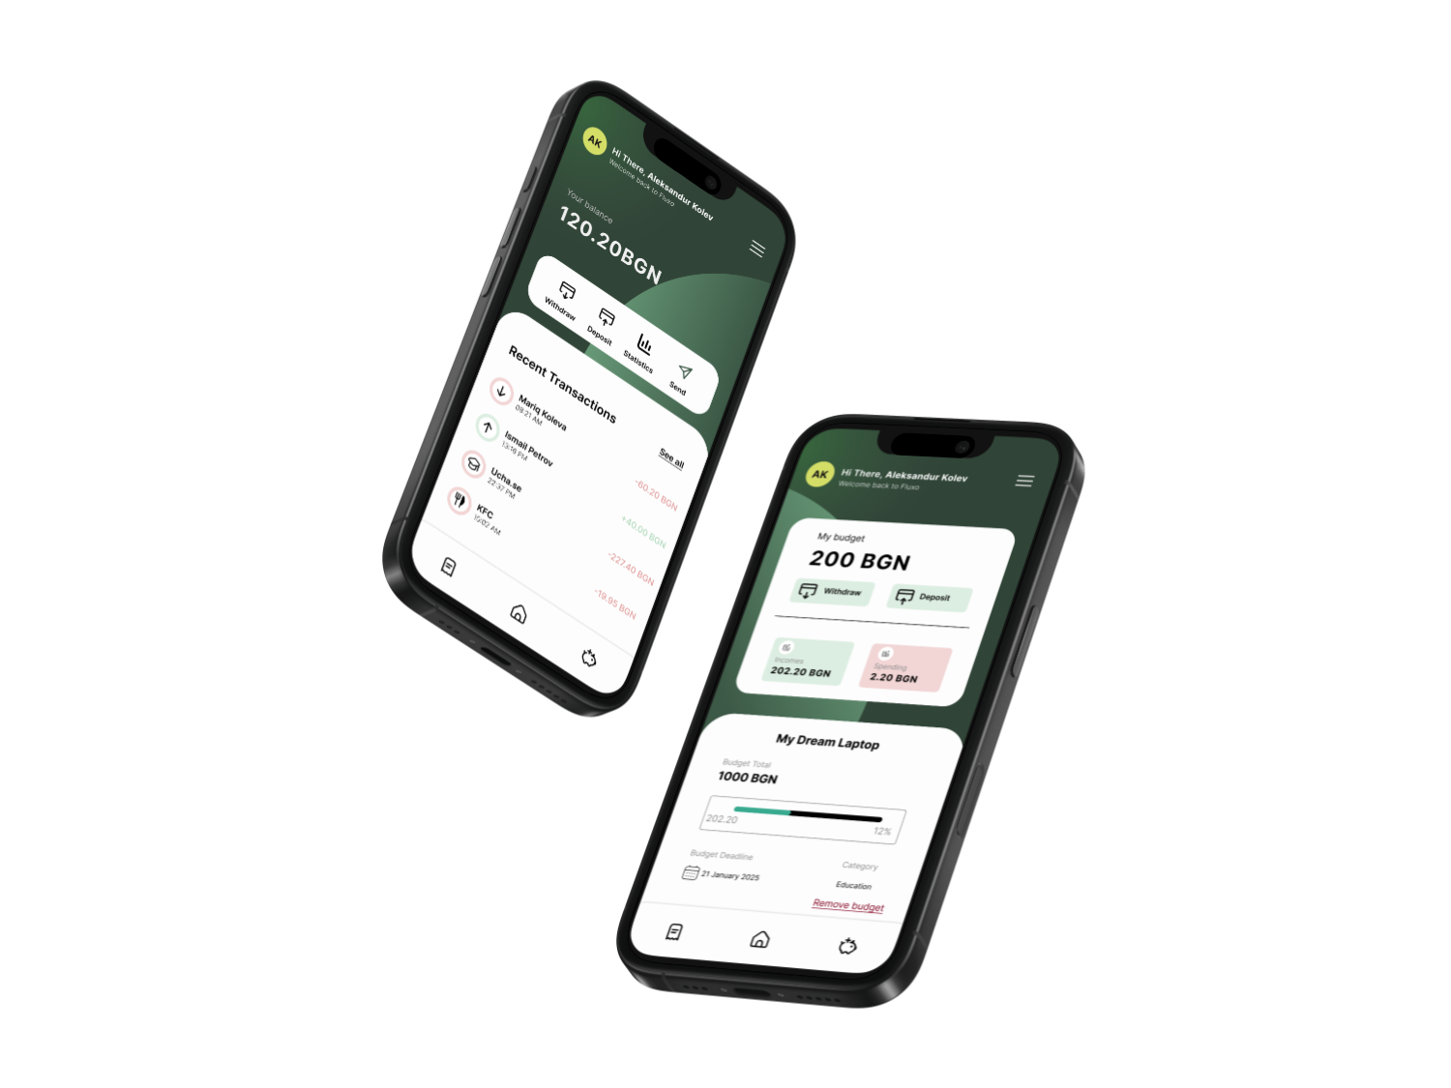Fluxo

Finance Mobile Application

Table of Contents

Team 2

Summary 4

Objectives 4

Main stages in development 4

Implementation 5

Block Scheme of Fluxo 6

# A black and blue light Description automatically generatedA black and blue light Description automatically generatedA black and blue light Description automatically generatedTeam

Scrum Trainer

Iva Dianova Raykova – 10g

**Developers**

Aleksandur Miroslavov Kolev – 10g

Vinichenko Oleksandr Oleksandrov – 10g

Petur Todorov Kostov – 10g

# A black and blue light Description automatically generatedSummary

## Objectives

Fluxo’s main goal is to help people manage their money more easily. By providing a user-friendly interface, we aim to simplify complex financial tasks and give users more control over their finances. The app offers features like budgeting, transactions, and money transfers, allowing users to handle essential financial tasks conveniently from their mobile devices.

## Main stages in development

1. **Reflection on the topic**  
   During the first days of our project, the team met and discussed ideas based on our topic ‘Finance Challenge’.
2. **Design**  
   The design was done by Iva Raykova and Aleksandur Kolev and when designing a new window, everyone's opinion was listened to and the recommendations were transferred to the Figma program.
3. **Development**  
   The development of Fluxo was a two-week collaborative effort, with each team member contributing consistently to avoid last-minute rush. Aleksandur Kolev handled the backend and database, ensuring secure and efficient data handling, while Iva Raykova and Oleksandr Vinichenko focused on a user-friendly front-end, and Petur Kostov developed the website. This steady, organized approach allowed us to deliver a reliable and polished financial app, combining functionality and ease of use.
4. **Introducing**  
   The team agreed that our presentation slides should be split up evenly.

# A black and blue light Description automatically generatedA black and blue light Description automatically generatedImplementation

Software for programming our project are [QT Creator](https://www.qt.io/product/development-tools) and [Visual Studio Code](https://code.visualstudio.com/)



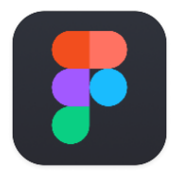For the creation of our design the main program is [Figma](https://www.figma.com/)

Our collaboration tools are [GitHub](https://github.com/), [Git](https://git-scm.com/) and [Microsoft Azure](https://azure.microsoft.com/en-us).





Programming languages we used are C++, TypeScript and QML



1. The technologies, libraries and instruments used in our project are [QT Creator](https://www.qt.io/product/development-tools), [React](https://react.dev/), [Vite](https://vite.dev/), [Tailwind](https://tailwindcss.com/) and [Shadcn](https://ui.shadcn.com/)



Software used for the presentation of the project are [Microsoft Word](https://www.microsoft.com/en-us/microsoft-365/word) and [Microsoft PowerPoint](https://www.microsoft.com/en-us/microsoft-365/powerpoint)



# Block Scheme of Fluxo



# A black and blue light Description automatically generatedA black and blue light Description automatically generatedConclusion

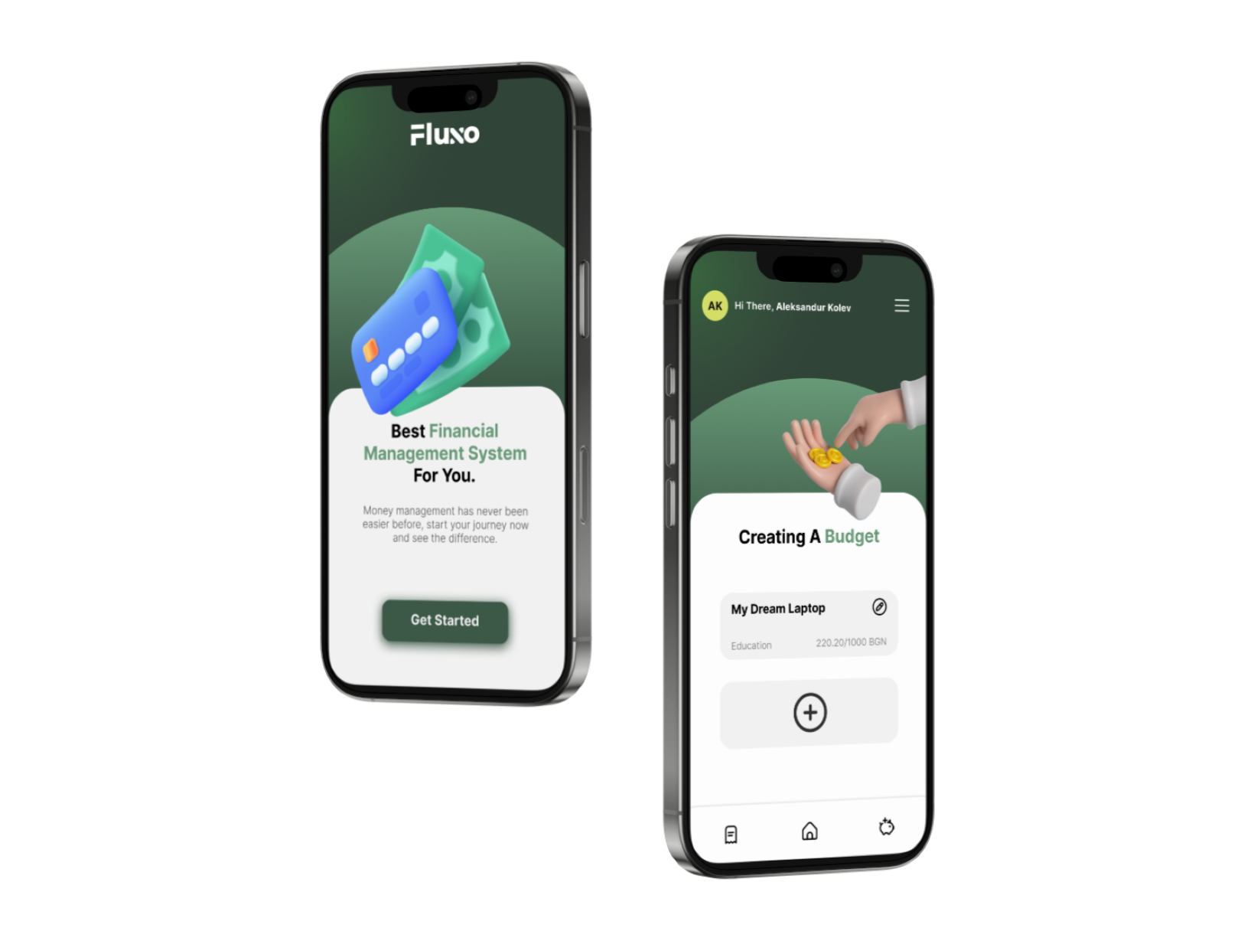Fluxo is a powerful and also user-friendly financial app that empowers individuals to manage their finances easily. By integrating essential features like budgeting, transactions, and transfers, it provides a comprehensive solution for personal finance management. With a clean, intuitive interface and reliable backend, Fluxo aims to simplify complex financial tasks and support users in achieving their financial goals. Whether tracking expenses, setting budget limits, or helping a friend in need, Fluxo is designed to make everyday financial decisions easier and more efficient.